- In a rectangular coordinate system the coordinate exes divide the plane into four regions called…
Cube
Quadrants
Circle
- An equation of the form 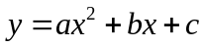 is called ….
Parabolic
Cubic
Quadratic
- Graph of f(x) =|x| is ……
Circle shape
V shaped
U shaped

- Y=f(x) +3 translation of the function is at 3 is ….. By c units
Up
Down
Left
Right
- Graph of y=|x-5| ……… of the graph y=|x| 5 units to the right to get the graph of y.
Reading
Translation
Creating
Definition
- By the definition and ………… be on the interval (xo, x1)
Greater than zero
Equal to zero
Less than zero
Less than and equal to zero
- Let f(x) is the function as x approaches to 0 then the limit from the positive will be …
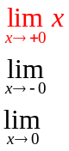
- Cot(x) discontinuous at …….
Cos(x) =0
Sin(x) = 0
Tan(x) =0
Cot(x) = 0
- If a function is differentiable then the function is also ……… on that point
Discontinues
No exit
Continuous
- Tan (5-3x) find differentiation w.r.t. x
-3sce² (5-3x)
3sce² (5-3x)
3cos (5-3x)
3cos² (5-3x)

- Derivative of the 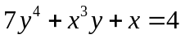 will be solved by …….. Method
Implicit
Explicit
Simple

- Constant function has the slope …..
Positive
Negative
Zero
- Decreasing function has the slope …….
Negative
Positive
Zero
- Consider two function 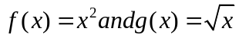 then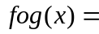..................
►
► 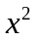
► 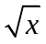
► None of these
- A function is said to be continuous function if the function is continuous on the interval

► 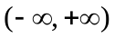
► 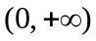
► 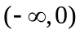
► None of these
- According to Power-Rule of differentiation, if 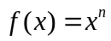 where is a real number, then
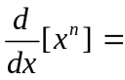
► 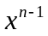
► 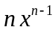
► 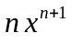
► 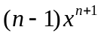
- 30⁰ = ________

► 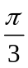
► 
► 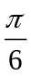
► 
- is a .............number
► Integer
► Rational
► Irrational
► Natural
- The equation of line of the form 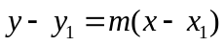 is known as

► Point-slope form
► Two points form
► Intercepts form
► Slope intercept form

- The set of rational number is a subset of
► Integers
► Natural numbers
► Odd integers
► Real number
Subjective
Question 21
Where the function 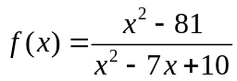 will be discontinues? [2marks]
Question 22
Find dy/dx at (-5, 6) if x²+y² = 9 [2marks]
Question 23
Does the limit of 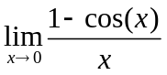exist or not? [3marks]
Question 24
If 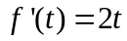 then find the intervals on which function will be increasing and decreasing. [3makrs]
Question 25
Find dy/dx if 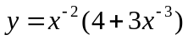 by product rule. [5marks]
Question 26
If 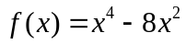 then find all the relative extreme by the first derivative rule. [5marks]

